Simulation Games – Reflection
In the first simulation game, our task was to manage a supply chain for drug delivery to hospitals. Initially, there were some misunderstandings regarding the delivery of the drugs. My group served as the main supplier, MedLager AB, which took orders from sub-suppliers. The drugs were manufactured in the KemLab, which could produce three batches at a time; however, our team was responsible for providing four batches—two for each sub-supplier.
We faced a challenge in maintaining a constant flow of supplies while also ensuring we had a reserve on hand. Our team's performance could have been enhanced with improved communication and a better division of responsibilities. Specifically, we could have organized ourselves into three teams: two teams tasked with taking orders from the sub-suppliers and supplying materials, and a third team responsible for receiving supplies from the lab. This third team would also oversee the maintenance of a steady flow of supplies and the management of our reserve stock.
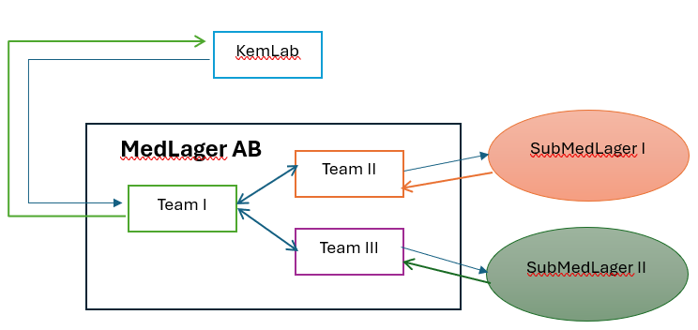
Dividing MedLager AB into smaller teams can enhance the efficiency of drug delivery and acquisition, potentially improving the overall model. By assigning specific tasks to different agents, each responsible for smaller assignments, we can reduce miscommunication and errors within the model.
In conclusion, clearly defining tasks and fostering constructive communication can make complex systems more manageable. This approach can also be implemented in simulations, serving as a learning process for tackling real-world challenges and understanding the potential outcomes and consequences for stakeholders.

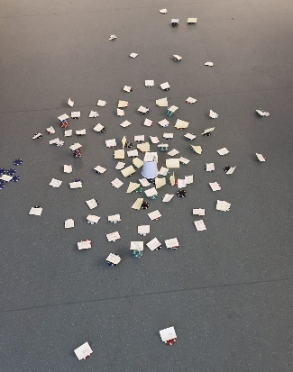
In the second simulation, our group was tasked with building a city together. Initially, everyone contributed ideas about what they deemed important to the city, but we lacked a clear structure. It appeared that everyone viewed it as a game with rules, and none of us took the time to reflect on the best approach to city planning. This resulted in a city that is centralized but still has the basic needs for living and thriving.
The simulation consisted of three rounds, and by the second round, a form of communication began to develop among us. However, this communication was somewhat vague regarding what was truly needed in the city and what we lacked. Discussions mainly took place with nearby members rather than involving the entire group. A full group discussion would have been beneficial in addressing different areas per subgroup, such as education, housing, food supply chains, administration, and energy, to help reduce potential biases in our planning.
This can be viewed as managing an interdisciplinary project that requires a collaboration of experts from various fields, such as engineering, design, marketing, and user experience. The goal would be to develop a comprehensive product that effectively meets the diverse needs of a wide range of clients. Each expert contributes their specialized knowledge by communicating with each other to ensure that the product not only performs well but also resonates with different target audiences, addressing specific preferences and requirements.

